Contents

Instructions: 2

Part One: Introduction 3

Dashboard definition 3

Tableau Stories 4

Hints 4

Part Two: Sales Representative and Calls Performance 5

Part Three: Company Sales Branches Comparison 6

Deliverables: 7

# Instructions:

* The workshop can be completed in **group of four (recommended)**.
* All members should work together to complete the workshop and they will receive the same mark.
* This workshop is worth 2.5% of the total course grade and will be evaluated through your written submission.
* Please submit the submission file(s) through Blackboard.
* **Only one person must submit for the group and only the last submission will be marked**.

# Part One: Introduction

The business world is *enamored* by dashboards. Why? Few static reporting tools emulate the interactivity and drill down capabilities of a dashboard, making dashboards an incredibly powerful decision-making tool.

In normally, you will likely create numerous data visualizations. Each of these visualizations gives you a snapshot of a story within the data. Each insight into the data answers a question or two. At times, the discovery and analysis phase are enough for you to make a key decision and the cycle is complete. In other cases, you will need to bring the snapshots together to communicate a complete and compelling story to your intended audience. Tableau allows you to bring together related data visualizations into a single dashboard. This dashboard could be a static view of various aspects of the data or a fully interactive environment, allowing users to dynamically filter, drill down, and interact with the data visualizations.

Allowing the audience to interact with a dashboard and change the details being displayed provides a means to shift context—leading to new and potentially important discoveries. Assembling dashboards in Tableau is fun for the designer and good dashboard design can delight audience.

## Dashboard definition

From a Tableau perspective, a **dashboard** is an arrangement of individual visualizations, along with other components such as legends, filters, parameters, text, containers, images, extensions, buttons, and web objects that are arranged on a single canvas. Ideally, the visualizations and components should work together to tell a complete and compelling data story. Dashboards are usually (but not always) interactive.

## Tableau Stories

A **story** is a sequence of visualizations that work together to convey information. You can create stories to tell a data narrative, provide context, demonstrate how decisions relate to outcomes, or simply make a compelling case with your data. A story is a sheet, so the methods to create, name, and manage worksheets and dashboards also apply to stories. Each individual sheet in a story is called a **story point**. The rationale for using Tableau stories is they are used to highlight the important parts of your data that you want to show to an audience. These emphasized points should answer your research question.

## Hints

When you make your visualizations be sure to add the necessary elements to make it a properly done one (i.e. ***Include title, annotations, sorting, coloring/highlighting***, etc. as you see fit to best communicate your message). Also,

* **Pay attention to data-to-ink ratio**
* **Apply Pre-Attentive Attributes to your Chart**
* **Apply design concepts to your Chart**
* **Add any annotation or labeling that can help you.**

Remember

* The measure **#calls equals volume of calls**. **Note the Tableau default is to sum measures**.
* In order to visualize data, you will need at least one measure (a dimension by itself will give you an empty table).
* If you get stuck, consult Tableau’s training resources <http://www.tableausoftware.com/learning/training>

# Part Two: Sales Representative and Calls Performance

1. Download **CustomerService.xlsx** from blackboard.
2. Open Tableau Desktop, and then connect to Microsoft Excel file
3. Make a visualization showing the **total number of calls**, separated by **incoming** and **outgoing**, for each **sales representative** (rep ID).
4. Make a visualization showing top 10 **sales representatives** have **the largest number of outgoing calls**.
5. Make a visualization showing top 10 **sales representatives** handled the **most calls (incoming and outgoing)** at the time block **starting at 2pm**.
6. Create a new dashboard by clicking the New Dashboard tab to the right of all existing worksheet tabs or by selecting Dashboard | New Dashboard from the menu.
7. Rename the new dashboard as **Sales Representative and Calls Performance**
8. Save your tableau file as **WS10.twbx**.

# Part Three: Company Sales Branches Comparison

Your CEO wants to have one chart that allows his/her to easily comprehend how many calls each **branch** of the company has, **broken out by the type of call** (call purpose). You are to make four visualizations to put in a dashboard (**Company Sales Branches Comparison**) to show your manager (one of which you’ll end up showing the CEO).

**Describe which of the four you think is best and why and include it as an annotation on that visualization.**

1. One focused on call purpose (Bar Chart, 3 groups: complaint, product support, sales support)
2. One organized by Branch (Bar Chart, 2 groups: north, south)
3. Call purpose Stacked Bar Chart (combining two branches into same stacked bar)
4. Branch focused Stacked Bar Chart (combining three call purposes into same stacked bar)

If the CEO wants to see the number of calls of branches and then has broke out by the type of all calls in a dashboard with two different visualizations we suggest bar charts for both cases since bar charts or better separated visually and can act as filter more userfriendly, However, the stacked bar chart may not be practically useful in term of using as a filter in a dashboard.

Besides, if we were allowed to combine both graphs in one graph which shows branches and purposes more clearly and efficiently, this graph is suggested:

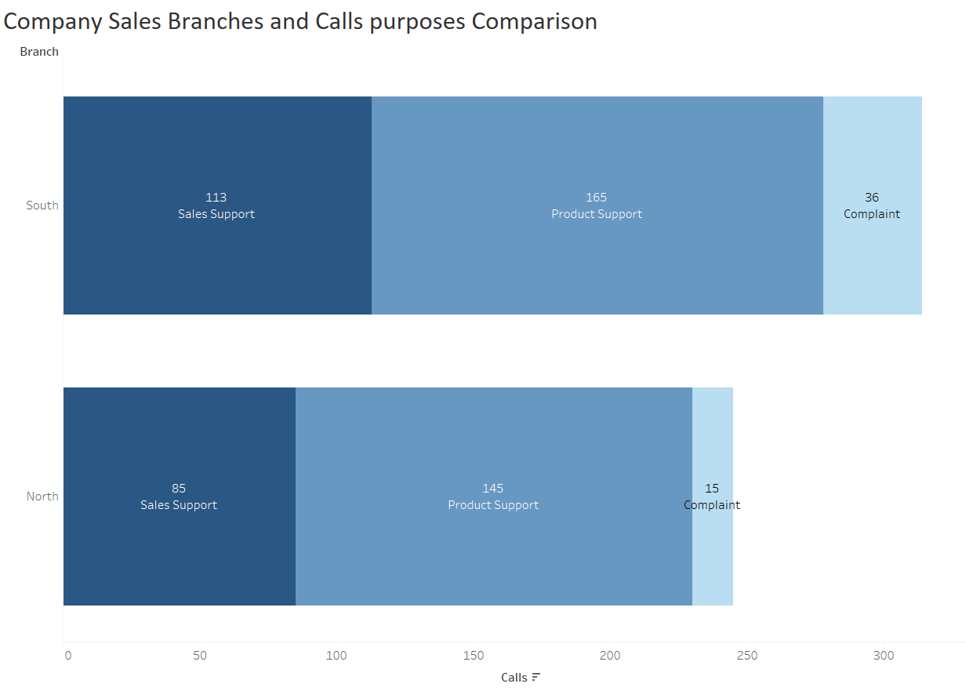

1. Create a new dashboard by clicking the New Dashboard tab to the right of all existing worksheet tabs or by selecting Dashboard | New Dashboard from the menu.
2. Rename the new dashboard as **Company Sales Branches Comparison**
3. Save your tableau file as **WS10.twbx**.

# Deliverables:

| SENECA’S ACADEMIC HONESTY POLICY |
| --- |
| As a Seneca student, you must conduct yourself in an honest and trustworthy manner in all aspects of your academic career. A dishonest attempt to obtain an academic advantage is considered an offense and will not be tolerated by the College. |

Add this declaration to your submission file:

I/WE Sepehr Salehi, Rongzhao Yi, Conghan Zheng and Roohalah Taraf ,declare that the attached assignment is our own work in accordance with the **Seneca Academic Honesty Policy**. I/We do not copy any part of this assignment, manually or electronically, from any other source including web sites, unless specified as references. I do not distribute my work to other students.

|  | Name | Task(s) |
| --- | --- | --- |
| 1 | Conghan Zheng | Part 2 |
| 2 | Rongzhao Yi | Part 2 |
| 3 | Sepehr Salehi | Part 3 |
| 4 | Roohalah Taraf | Part 3 |

***Using Blackboard, submit the following files***

1. **Pdf File**
2. **WS10.twbx**

Save your group work as

< **ZAA.2231 10** >_ws10.twbx